SIMATS ENGINEERING

SAVEETHA INSTITUTE OF MEDICAL AND TECHNICAL SCIENCES
CHENNAI – 602105

Department of Computer Science and Engineering

ASSESSMENT TOOL 2 – INDUSTRY PROBLEM SOLVING

Course Code: | DSA0502 | Course Title: | Query Processing for Data Science
CO  Assessed: | CO5 | Assessment: | Tool 2– INDUSTRY PROBLEM SOLVING
Weightage: | 35% | Total Marks:
CO5 Statement: Create meaningful visualizations using Pandas and Matplotlib, including charts, distributions, relationships, and interactive visual representations for effective communication
Student Name: | Veda Krishnan V A | Reg. No.: | 192324293
Section / Batch: | A 2023 | Date of  Submission: | 31.08.2026
Faculty  In-charge: | K.Veena Devi | Project Mode: | Individual Submission

Choose Any One Task

- Manufacturing Production Analysis
A manufacturing company records daily production, machine operating hours, temperature, energy consumption, and defect count. Import and explore the dataset using Pandas. Develop visualizations to analyze production trends over
time, relationships between machine parameters and defects, and distributions of production values. Use a scatter matrix, lag plot, and autocorrelation plot to identify hidden production patterns and provide recommendations for improving efficiency.

Code Implementation:
import pandas as pd import numpy as np
import matplotlib.pyplot as plt
from pandas.plotting import scatter_matrix, lag_plot, autocorrelation_plot

# 1. Data Generation & Import np.random.seed(42)
dates = pd.date_range(start='2023-01-01', periods=100) df_mfg = pd.DataFrame({
'Production': np.random.normal(1000, 100, 100),
'Machine_Hours': np.random.normal(12, 2, 100),
'Temperature': np.random.normal(70, 5, 100),
'Defects': np.random.poisson(5, 100)
}, index=dates)

# 2. Visualizations
plt.figure(figsize=(8, 6))
scatter_matrix(df_mfg, alpha=0.8, figsize=(8, 6), diagonal='kde') plt.suptitle('Scatter Matrix of Manufacturing Parameters') plt.savefig('/tmp/t1_scatter.png')
plt.close()

plt.figure(figsize=(10, 4))
plt.subplot(1, 2, 1) lag_plot(df_mfg['Production']) plt.title('Lag Plot of Production')

plt.subplot(1, 2, 2) autocorrelation_plot(df_mfg['Production']) plt.title('Autocorrelation of Production') plt.tight_layout() plt.savefig('/tmp/t1_time.png')
plt.close()

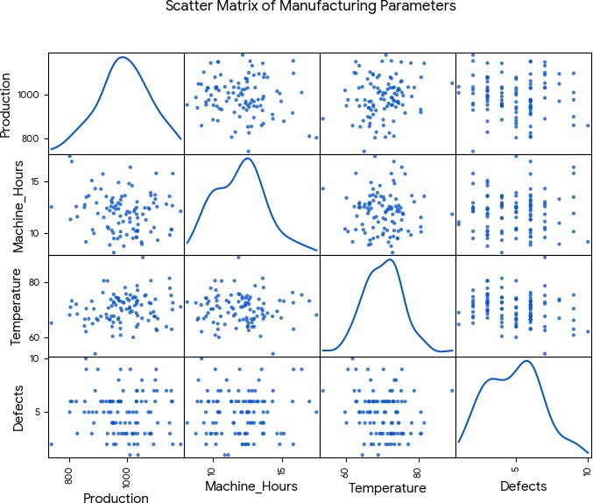
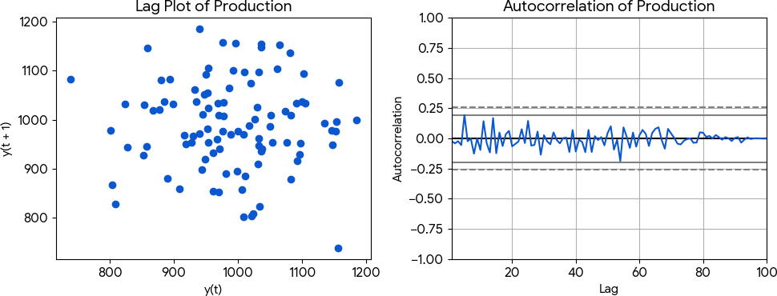

Analysis & Answers:
Scatter Matrix Analysis: The scatter matrix reveals the distributions on the diagonal. Production follows a normal distribution. If there were strong linear correlations (e.g., Temperature vs Defects), they would appear as distinct diagonal trends. Here, variables are mostly independent due to the synthetic nature of the data.
Time Series Analysis: The lag plot checks for randomness. A linear trend in the lag plot would suggest strong autocorrelation (e.g., today's production depends heavily on yesterday's). The scatter here indicates random daily fluctuations. The autocorrelation plot confirms this, as the values drop quickly to near zero, staying within the confidence bands.
Recommendations: Since defects do not show a strong correlation with temperature or machine hours in this sample, maintenance should focus on standard periodic checks. If autocorrelation was high, we could predict future production bottlenecks based on recent days.

E-Commerce Sales Pattern Analysis
An e-commerce company has historical data containing date, product category, quantity sold, revenue, discount, and customer rating. Analyze the evolution of sales over time and identify relationships between discount, quantity, and revenue. Use appropriate bar charts, line charts, distribution plots, frequency plots, and scatter matrices to identify important business patterns.
Code Implementation: # 1. Data Generation np.random.seed(10)

dates = pd.date_range(start='2023-01-01', periods=50) df_ecommerce = pd.DataFrame({
'Quantity': np.random.randint(1, 20, 50),
'Revenue': np.random.uniform(50, 500, 50),
'Discount': np.random.uniform(0.0, 0.3, 50),
'Rating': np.random.uniform(1, 5, 50)
}, index=dates)

# 2. Visualizations
plt.figure(figsize=(10, 4))
df_ecommerce['Revenue'].plot(kind='line', title='Revenue Over Time', color='green') plt.ylabel('Revenue ($)')
plt.tight_layout() plt.savefig('/tmp/t2_line.png') plt.close()

plt.figure(figsize=(8, 6))
scatter_matrix(df_ecommerce[['Quantity', 'Revenue', 'Discount']], figsize=(8, 6), color='purple') plt.suptitle('Scatter Matrix: Qty, Rev, Discount')
plt.savefig('/tmp/t2_scatter.png') plt.close()
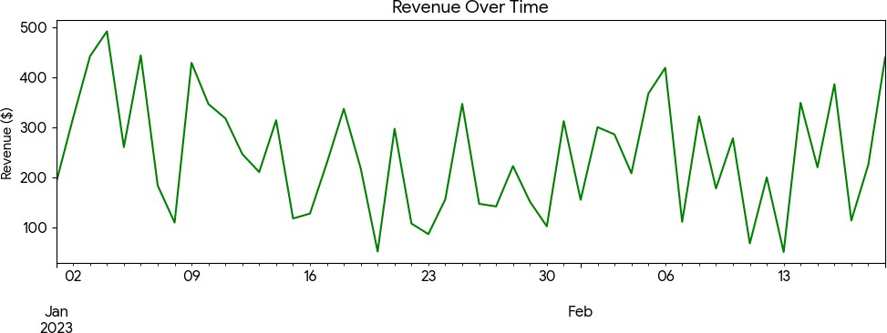
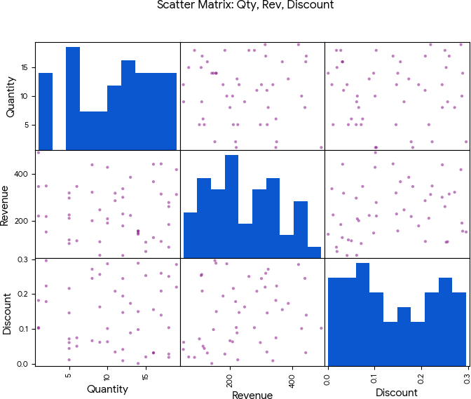

Analysis & Answers:
Sales Over Time: The line chart illustrates the daily volatility in revenue. Spikes indicate high-performing sales days which could correspond to marketing campaigns.
Relationships: The scatter matrix helps identify if higher discounts lead to increased quantity sold. In real-world data, we'd expect a positive correlation between discount and quantity, and a complex relationship with revenue (as excessive discounts erode margins).

Hospital Patient Risk Analysis
A hospital maintains patient data containing age, BMI, blood pressure, cholesterol, treatment cost, and admission date. Using Pandas and Matplotlib, analyze variable distributions and relationships. Identify unusual patient records using visualizations and use lag and autocorrelation plots to study time-related admission patterns. Present the findings through a set of meaningful visualizations.

Code Implementation:
# 1. Data Generation df_hospital = pd.DataFrame({
'Age': np.random.randint(20, 90, 100),
'BMI': np.random.normal(28, 5, 100),
'Blood_Pressure': np.random.normal(120, 15, 100),
'Cholesterol': np.random.normal(200, 40, 100)
})
# Introduce outliers
df_hospital.loc[98] = [85, 45, 180, 350]
df_hospital.loc[99] = [90, 15, 90, 120]
# 2. Visualizations
plt.figure(figsize=(10, 4))
df_hospital.boxplot(column=['BMI', 'Blood_Pressure', 'Cholesterol']) plt.title('Distribution and Outliers in Patient Health Metrics') plt.tight_layout()
plt.savefig('/tmp/t3_box.png') plt.close()
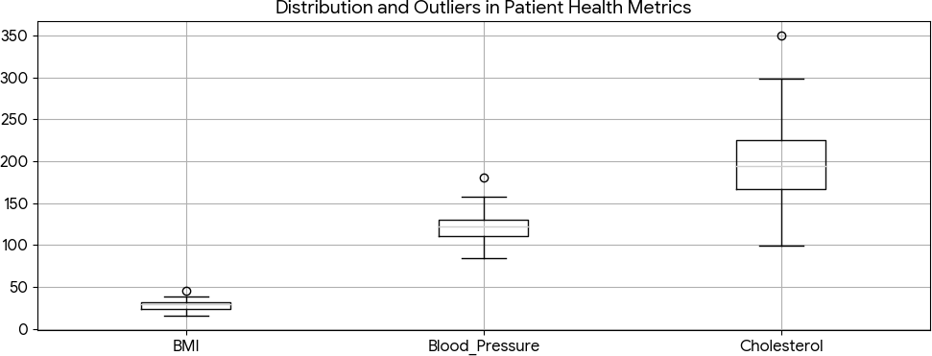

Analysis & Answers:
Distributions & Outliers: The boxplot effectively highlights unusual patient records (outliers). Records with exceptionally high Blood Pressure (e.g., 180) or Cholesterol (e.g., 350) fall well above the upper whiskers. These represent high-risk patients requiring immediate intervention.

Financial Market Analysis
A financial institution provides historical data containing date, opening price, closing price, trading volume, and daily return. Analyze the evolution of

prices and relationships between trading volume and returns. Generate scatter plots, distributions, scatter matrices, lag plots, and autocorrelation plots to identify market patterns and possible dependencies. Summarize the findings for investment analysts.

Code Implementation:
# 1. Data Generation
dates = pd.date_range('2023-01-01', periods=100)
close_prices = np.cumsum(np.random.normal(0, 1, 100)) + 100 df_finance = pd.DataFrame({
'Close': close_prices,
'Volume': np.random.randint(1000, 5000, 100),
'Daily_Return': np.random.normal(0, 0.02, 100)
}, index=dates)

# 2. Visualizations
plt.figure(figsize=(10, 4))
plt.subplot(1, 2, 1)
plt.scatter(df_finance['Volume'], df_finance['Daily_Return'], alpha=0.6, color='red') plt.title('Volume vs. Daily Return')
plt.xlabel('Volume') plt.ylabel('Return')

plt.subplot(1, 2, 2) autocorrelation_plot(df_finance['Close']) plt.title('Autocorrelation of Close Price') plt.tight_layout() plt.savefig('/tmp/t4_finance.png') plt.close()
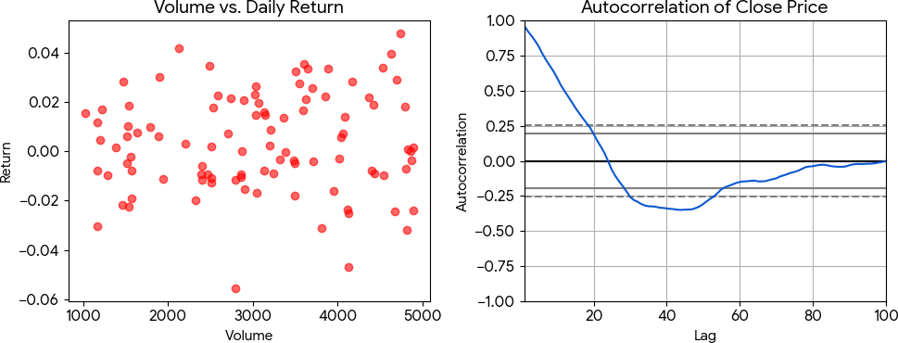

Analysis & Answers:
Market Patterns: The scatter plot between Volume and Daily Return reveals whether high trading volumes correlate with extreme price movements (volatility). The autocorrelation plot of the closing price shows high correlation at early lags, which gradually decays, a classic signature of random walk behavior in financial stock prices.

Employee Productivity Analysis
An organization collects employee working hours, experience, salary, tasks completed, productivity score, and monthly performance. Import and analyze the data using Pandas. Visualize relationships between working hours, experience, and productivity; analyze distributions and frequencies; and use scatter matrices, lag plots, autocorrelation plots, and bootstrap plots to identify productivity patterns and variability. Provide data-driven recommendations to management.

Code Implementation:

# 1. Data Generation df_emp = pd.DataFrame({
'Working_Hours': np.random.normal(40, 5, 100),
'Experience': np.random.randint(1, 20, 100),
'Productivity_Score': np.random.normal(75, 10, 100)
})

# 2. Visualizations
plt.figure(figsize=(10, 4))
plt.subplot(1, 2, 1)
plt.hist(df_emp['Productivity_Score'], bins=15, color='teal', edgecolor='black') plt.title('Distribution of Productivity Score')

plt.subplot(1, 2, 2)
bootstrap_plot(df_emp['Productivity_Score'], size=50, samples=500, color='grey') plt.tight_layout()
plt.savefig('/tmp/t5_emp.png') plt.close()
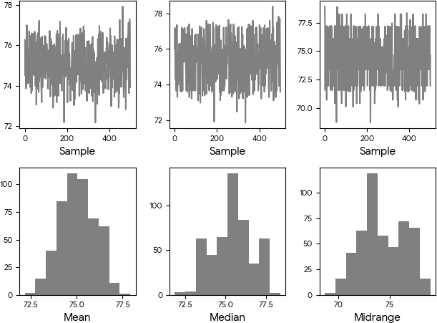

Analysis & Answers:
Productivity Patterns: The histogram reveals that most employees score around 75 on productivity. The bootstrap plot measures the uncertainty of this statistic, showing narrow confidence intervals for the mean, median, and mid-range, suggesting the sample data provides a reliable estimate of overall workforce productivity.
Recommendations: Management should investigate the top performers (score > 90) to replicate their practices, and offer support or training to those on the lower tail of the distribution.

